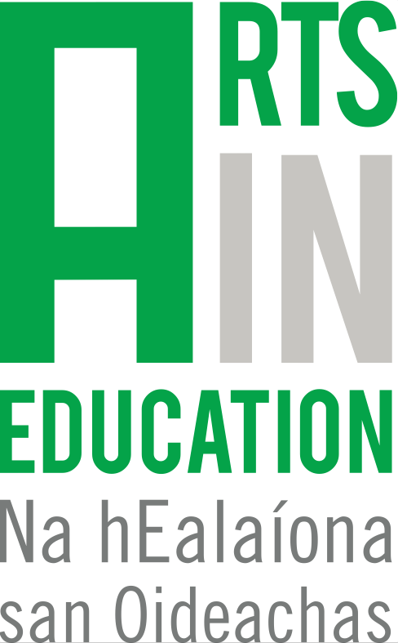

Arts in Education Portal – Documentation Award
Photographic Imagery & Video Consent Form

About
The Arts in Education Portal (www.artsineductaion.ie) is the key national digital resource of arts and education practice in Ireland. Launched in 2015 the portal was one of the objectives of the Arts in Education Charter. Its ethos is about building a community of practice within arts and education, and providing a space where both artists and teachers can be supported and inspired. The portal provides a platform through which good collaboration practice in arts-in-education and arts education is supported, developed and enhanced.

Photographic Imagery & Video Recording

The Arts in Education Portal would like to take photos and video of people (including children) during the project engagement sessions. The Portal would like to use these images for the purpose of sharing the project on the portal website, at events, in our newsletter and our social media channels.

I agree/disagree for the images of me/my child to be used for the purposes outlined above, please tick below:

AGREE [ ] DISAGREE [ ]

Name: (Please Print) __________________________________

Child/Young Person Name (if applicable):

(Please Print) ________________________________________

SIGNED: DATE:

For more information or queries please contact the Arts in Education Portal Team at mailto:editor@artsineducation.ie

