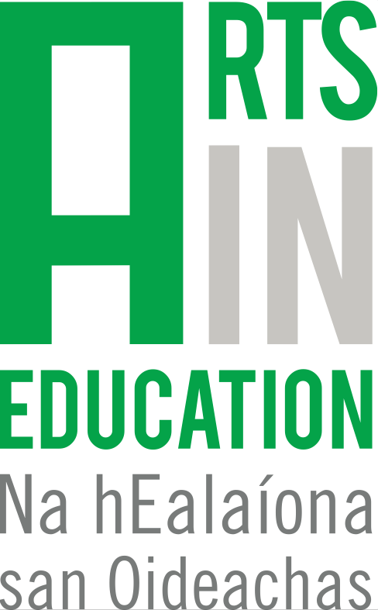 Arts in Education Portal
Submission template – Project / Partnership
Project facts:

Name of project:
Name of artist(s):
Name of teacher(s):
Name of school or participant group:
Number of participants:
Region:
Age/ Class of children:
Primary or post-primary:
Dates of project:
Art form(s):

Agency leading or managing project:
Other partners and/or funders:
Key themes/ lines of enquiry:
Curriculum strands:
Web links:
Research or relevant publications:

About the project
Guidelines: (Please include the perspectives of both artist and teacher, and where possible, the children)

Tell us the story of your project – What was the impetus? What was it about? Who was involved? How did you begin?

How were the ideas developed and how did the young people, artist and teacher work together?

What was your personal experience of the project in terms of successes and challenges?

What was significant for you about the project that is worth sharing?

Has anything changed in your work as a result of the project?

Spotlight on Artist/ Teacher/ Curator/ Agency:
Tell us a bit about you, your work, why you are engaged in collaborative practice, previous projects etc. (max 250 words). Include relevant web links where required.

*Please also supply a high-resolution headshot or image for each individual/org represented.

Artist (s):

Teacher (s):

Other:
(Curator, agency etc)

