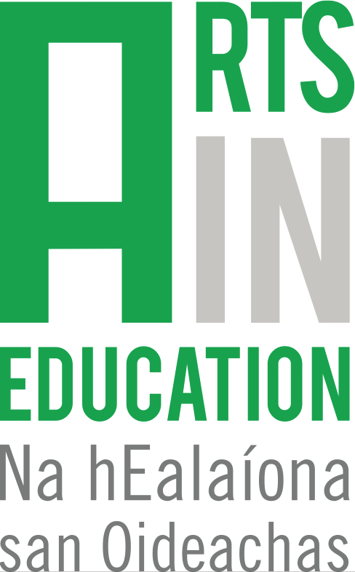 Arts in Education Portal
Submission template – News item

Which of the following categories does your news item relate to?

(Please tick)
An opportunity for artists and/or teachers (e.g. CPD, courses, training, life-long learning)

An upcoming project or event
(For school groups, teachers, artists to get involved in)

News about policy or sector

About

Title of news item

Name of author/ agency

Date or deadline (If applicable)

Information
(Please provide information here about your opportunity or event – max. 150 words)

Relevant links

- Please also provide one high-resolution image to accompany your news item

Categorisation

The following will help your news item to be found via the search function:

Principal art form
School level (Primary/Post-primary or both)
Region / Location

